Online in no time
In this form we want to support you on creating your Premium Company Ad for the LUMITOS B2B newsletters, so it can go online as soon as possible.

Your Premium Company Ad
Your Premium Company Ad will be displayed in the newsletter as shown below. The keywords should entice interest in your range of offerings and animate to clicking.

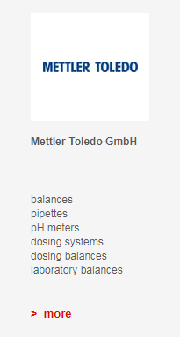

Five Product- or Service Keywords
Please enter up to five keywords. Each keyword can be a maximum of 20 characters long.
German | Englisch

Please send us the filled form to order@lumitos.com by email. From here on, we will take care of everything else.

