Online in four steps
In this blank we want to support you on creating your Premium Newsletter Reference for the English-language B2B newsletters of LUMITOS, so it can go online as soon as possible. Just follow our 4-step plan and fill all the required information in the grey fields.
Your Premium Newsletter Reference
Your Premium Newsletter Reference will be displayed in the newsletter as shown here. The headline and subheader should grasp the reader’s attention and animate them to clicking.
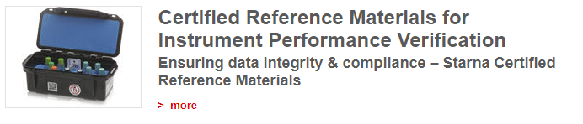

Identification
Please indicate the name of your product or catalog (for internal use only)
Headline
Maximum of 100 characters per language including spaces. Focus on user benefits. The headline will be formatted according to “Chicago Manual of Style”.
Subheader
Maximum of 100 characters per language including spaces.

Teaser Text for analytica-world news
The teaser text is only required for the analytica-world news. Maximum of 150 characters per language including spaces.
Newsletter Text in English

Please send us the filled out blank to order@lumitos.com by email. From here on, we will take care of everything else.

