Online in no time
In this blank we want to support you on creating your Premium Company Ad for the LUMITOS B2B newsletters, so it can go online as soon as possible. Just fill out all the required information in the grey fields.

Your Premium Company Ad
Your Premium Company Ad will be displayed in the newsletter as shown below. The keywords should entice interest in your range of offerings and animate to clicking.

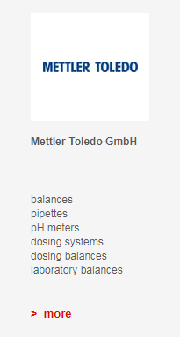

Five Product- or Service Keywords
Please enter the German keywords here.

Please enter the English keywords here.

Please send us the filled out blank to order@lumitos.com by email. From here on, we will take care of everything else.

